DOMAINE DE LA CROIX
CUVEE IRRRESISTIBLE 2017
PROVENCE

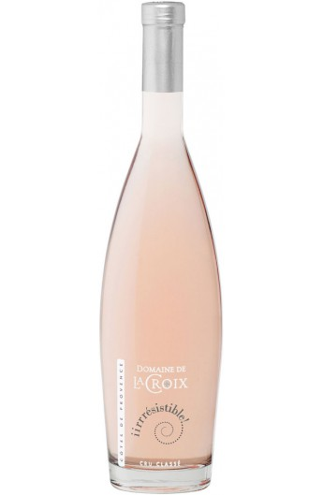
The prestige and the elegance of the peninsula of Saint Tropez express themselves trough the wine of the Domaine de La Croix, (Cru Classe de Provence), an anthology of rich flavours of fruits and precious balances. Created in 1882, the Domaine de La Croix extends over 180 ha among wich 100 ha of vineyards. In 2001, the group Bollore acquires this domain and takes up with the excellence of this soil distinguished, from 1955, as exceptional « Cote de Provence ».

TERROIR ALCOHOL
Sand-schistous soils 13%
GRAPE VARIETY WINEMAKING
30% Grenache Cooling of the vintage, settling of the juice,
25% Cinsault fermentation in stainless steel with thermo-
15% Tibouren regulation at a low temperature. Aging on
15% Mourvedre the lees.

SERVICE TEMPERATURE
10 – 12°C

TASTING NOTES
All in roundness a fresh and aromatic bouquet, a full silky and fruity mouth and a frank and supple finish.

FOOD PAIRAING
As an aperitif, or as an accompaniment to salads or grilled fish. A very elegant bottle that pleases hugely female, ideal to offer.

